**CE警告標誌國際標準(ISO 7010)之簡述及其特徵:**

**A、警告用途**

特徵: 黃底黑三角型

|  |  |  |  |  |  |  |  |  |  |
| --- | --- | --- | --- | --- | --- | --- | --- | --- | --- |
| ELECTRICAL SHOCK  A-001 | VOLTAGE HAND SHOCK  A-002 | | VOLTAGE BODY SHOCK  A-003 | | DRAW IN CRUSH  A-004 | | | KICKBACK  A-005 | |
| CUTTING FINGER-BLADE1  A-006 | CUTTING FINGER-AUGER  A-007 | | Cutting of Fingers or Hand  A-008 | | ENTANGMENT-PINCH POINT-2  A-009 | | | CUTTING FINGER-STRAIGHT BLADE  A-010 | |
| ENTANGMENT-PINCH POINT-3  A-011 | MOVING PARTS GEAR CRUSH  A-012 | | CRUSH FROM ABOVE  A-013 | | HAND CRUSH FROM ABOVE  A-014 | | | ENTANGMENT-PINCH POINT  A-015 | |
| CUTTING FINGER-BLADE2  A-016 | ENTANGLEMENT-CHAIN  A-017 | | TRIPPING  A-018 | | FALL  A-019 | | | A-020 | |
| Entanglement-PINCH POINT  A-021 | SLIP SURFACE  A-022 | | LASER BEAM  A-023 | | CORROSIVE MATERIAL  A-024 | | | SKIN PUNCTURE-AIR PRESSURE  A-025 | |
| SKIN PUNCTURE-HYDRAULIC  A-026 | NON-IONIZING RADIATION  A-027 | | FLYING DEBRIS  A-028 | | TOXIC POISION  A-029 | | | BIOLOGICAL  A-030 | |
| UV LIGHT  A-031 | | EXplosive Material  A-032 | | EXPLOSIVE-RELEASE PRESSURE  A-033 | | EXPLOSIVE  A-034 | FIRE WARNIG  A-035 | |
| Hot Surface Underneath  A-036 | | Hot Surface Underneath-2  A-037 | | HOT SURFACE  A-038 | | Battery Hazard  A-039 | GENERAL WARNING  A-040 | |
| BODY CRUSH  A-041 | | HAND CRUSH FROM ABOVE-HEAVEY  A-042 | | hand-crush  A-043 | | FREEZING  A-044 | Cutting Of Fingers Or Hand/Moving Part Label  A-045 | |
| ISO W014 - Forklift Hazard  A-046 | | ISO W019-Body Crush / Tipover Hazard Label  A-047 | | Radioactive Material  A-048 | | ISO W009 - Biological Hazard  A-049 | A-050 | |
| Cut or Sever Hazard  A-051 | | Cutting Of Fingers Or Hand/Angled Blade Label  A-052 | | Cutting Fingers Hand Blade Label  A-053 | | Cutting of Fingers or Hand/Engine Fan Label  A-054 | Cutting Of Fingers Or Hand/Rotating Shaft Label  A-055 | |
| Cutting Of Fingers Or Hand/Rotating Blade Label  A-056 | | Non-Ionizing Radiation Electromagnetic Hazard Label  A-057 | | Symbol Rotating Shaft  A-058 | | Pinch Point/Entanglement  A-059 | ISO W018 - Automatic Start-up  A-060 | |
| Loud Noise (with symbol)  A-061 | | Hand Crush/Rotating Blade (with symbol)  A-062 | | Pinch Point/Entanglement  A-063 | | Hand Crush / Moving Parts Label  A-064 | Pinch Point/Entanglement  A-065 | |
| Pinch Point/Entanglement  A-066 | | Pinch Point Entanglement Label  A-067 | | Pinch Point/Entanglement  A-068 | | Pinch Point Entanglement Label  A-069 | Lifting Hazard  A-070 | |
| ISO W006 Strong Magnetic Field Label  A-071 | | ISO W015-Body Crush / Force Above Label  A-072 | | ISO W022 - Sharp Points  A-073 | | Electric Ground Hazard  A-074 | Cutting Fingers Hand Blade Label  A-075 | |
| Electrocution Voltage Hazard  A-076 | | Explosion (with symbol)  A-077 | | Flying Debris And Loud Noise (Symbol) Label  A-078 | | Hand Crush Force Side Label  A-079 | Hand Crush / Force From Below Label  A-080 | |
| Hand Crush Force Side Label  A-081 | | Hand Crush / Force From Side Label  A-082 | | Hand Crush / Force From Side Label    A-083 | | Hand Crush / Force From Side Label  A-084 | Hand Crush / Pinch Point Label (Symbol)  A-085 | |
| Hand Crush Force Side Label  A-086 | | ISO W020 - Overhead Obstacles  A-087 | | ISO W024-Hand Crush/Force From Above Label  A-088 | | Symbol Rotating Shaft  A-089 | ISO W027 - Optical Radiation  A-090 | |
| ISO W028 - Oxidizing Materials  A-091 | | Pinch Point Entanglement Label  A-092 | | Pinch Point/Entanglement  A-093. | | A-094 | A-095 | |
|  | |  | |  | |  |  | |
| A-096 | | A-097 | | A-098 | | A-099 | A-100 | |
| A-0101 | | A-0102 | | A-0103 | | A-0104 | A-0105 | |
| A-0106 | | [20090624204302s](http://ireada.twcom.net/cgi-bin/big5/shop/pu3102?q163=&q168=20090617171905&q167=&time=14:31:31&qctrl=20110113143126122.118.0.125.sdata&q1=fu6v2&q24=&q22=898&q25=1&q30=20090617171905)  A-0107 | | A-0108 | | A-0109 | A-0110 | |
| A-0111 | |  | |  | |  |  | |

B、**禁止用途**

特徵: 紅色圓框及左斜線

|  |  |  |  |  |
| --- | --- | --- | --- | --- |
| Do Not Lift With Hook Label  B-001 | Do Not Operate Guard Removed Label  B-002 | Do Not Operate With Guard Removed Label  B-003 | Do Not Remove Plug  B-004 | Do Not Switch  B-005 |
| ISO Label - Do Not Obstruct  B-006 | ISO P001 - General Prohibition  B-007 | ISO P002 No Smoking Label  B-008 | ISO P003 - No open Flame  B-009 | ISO P004 - No Thoroughfare  B-010 |
| ISO P005 - No Drinking Water  B-011 | ISO P006 - No Forklifts/Industrial Vehicles  B-012 | ISO P007 - No Pacemaker Wearers  B-013 | ISO P008-No Metal Or Watches Label  B-014 | ISO P010 - Do Not Touch  B-015 |
| ISO P013 - No Activated Phones  B-016 | ISO P019 Do Not Step Label  B-017 | ISO P022-No Food Or Drink Label  B-018 | No Unauthorized Access  B-019 | No Dumping (Drain)  B-020 |
| B-021 | http://124.219.27.245/big5/shop/pu31/20090617171905/20090622002300.gif  B-022 | B-023 | B-024 | door not open  B-025 |
| B-026 | B-027 | B-028 | B-029 | B-030 |

C、**強制用途**

特徵: 圓型藍底白色圖案

|  |  |  |  |  |
| --- | --- | --- | --- | --- |
| [Center of Gravity  Label](http://www.mysafetylabels.com/MSL/ISO-Mandatory-Center-Of-Gravity-Safety-Label/SKU-LB-0029.aspx)  C-001 | [Forklift Point](http://www.mysafetylabels.com/MSL/ISO-Mandatory-Forklift-Point-Safety-Label/SKU-LB-0026.aspx)  C-002 | [Forklift Point](http://www.mysafetylabels.com/MSL/ISO-Mandatory-Forklift-Point-Safety-Label/SKU-LB-0027.aspx)  C-003 | [Hairnet Required Symbol Safety Label](http://www.mysafetylabels.com/labels/hairnet-required-mandatory-label/sku-lb-1633.aspx)  C-004 | [Wear Head and Eye Protection Symbol Safety Label](http://www.mysafetylabels.com/labels/head-and-eye-protection-required-label/sku-lb-1631.aspx)  C-005 |
| [Lifejacket Required Symbol Safety Label](http://www.mysafetylabels.com/labels/lifejacket-required-mandatory-label/sku-lb-1632.aspx)  C-006 | [Lock-Out In De-Energized State Symbol Label](http://www.mysafetylabels.com/labels/lock-out-in-de-energized-state-mandatory-label/sku-lb-1634.aspx)  C-007 | [Read Operators Manual Symbol Safety Label](http://www.mysafetylabels.com/labels/read-operators-manual-symbol-mandatory-label/sku-lb-1630.aspx)  C-008 | [Use Guards Symbol Safety Label](http://www.mysafetylabels.com/labels/use-guards-mandatory-label/sku-lb-1635.aspx)  C-009 | [ISO 3864-2 Refer Operator'S Manual Label](http://www.mysafetylabels.com/Safety-Labels/ISO-Label-Refer-to-Operators-Manual/SKU-LB-0458.aspx)  C-010 |
| ISO M001 - General Mandatory Action  C-011 | ISO M003 - Wear Ear Protection  C-012 | ISO M004 - Wear Eye Protection  C-013 | ISO M006 - Disconnect Mains Plug  C-014 | ISO M008 - Wear Foot Protection  C-015 |
| ISO M009 - Wear Safety Gloves  C-016 | ISO M010 - Wear Protective Clothing  C-017 | ISO M011 - Wash Your Hands  C-018 | ISO M013 - Wear Face Shield  C-019 | ISO M014 - Wear Hard Hat  C-020 |
| ISO M016 - Wear a Mask  C-021 | ISO M017 - Wear a Respirator  C-022 | ISO M018 Wear Safety Harness Label  C-023 | Lift Point Label  C-024 | Lock Out Electric Power  C-025 |
| Two Person Lift  C-026 | Wear Full Body Protection  C-027 | C-028 | C-029 | C-030 |

D、**火災相關**

特徵: 方形紅底白色圖案

|  |  |  |  |  |
| --- | --- | --- | --- | --- |
| fire  D-001 | FIRE EXTINGUISHER  D-002 |  |  |  |

**CE 標誌規格規範**

所有銷往歐盟之機械產品須貼附如下規範之CE 標誌，此標誌可直接印在機器銘牌上或另外以防水防撕毀之貼紙製作貼附。最小不得小於5mm

***The CE marking consists of the symbol shown below and the last two figures of the year in which the mark was affixed.***

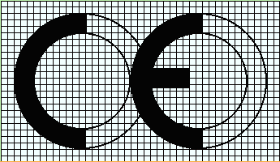

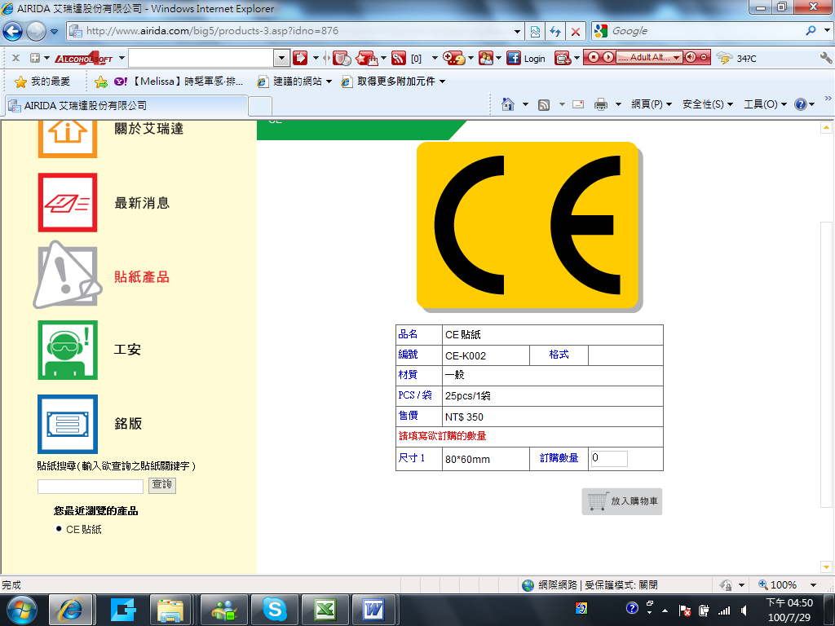



***The proportions of the above symbols for "CE" marking must be kept when reduced or increased in size.***

***The different elements of the CE marking should have materially the same vertical dimensions, which should not be less than 5 mm. This minimum size may be waived for small machinery.***